**EE49001: Control and Electronic System Design**

Assignment-2: Inverted Pendulum, Part:2

Submitted By:

21EE30004: Anirvan Krishna | 21EE30001: Aditya Kumar

# We want to design a controller with both $θ$ and $x$ feedback such that the following specifications are met: settling time $≤ 5s$ and phase margin $≥ 40°$

# Considering the control system architecture:

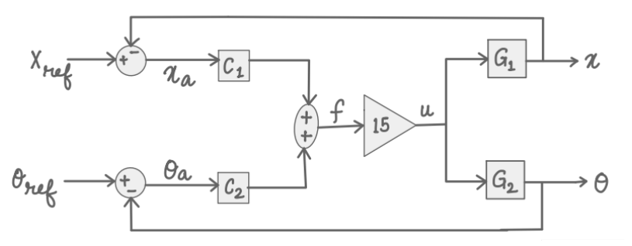

## Previous Data

From the previous part we know that,

$$G_{1}=\frac{X}{U}=\frac{\frac{1}{M}\left(s^{2}-\frac{g}{l}\right)}{s^{2}\left(s^{2}-\frac{\left(M+m\right)g}{Ml}\right)} \\ G_{2}=\frac{Θ}{U}=-\frac{\frac{1}{Ml}}{s^{2}-\frac{\left(M+m\right)g}{Ml}}$$

Numerical Values of transfer function:

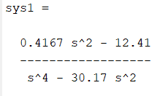 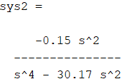

Fig: Transfer function $\frac{X\left(s\right)}{U\left(s\right)}$ Fig: Transfer function $\frac{Θ\left(s\right)}{U\left(s\right)}$

## Characteristic Equation

From the above block diagram these following relations can be deduced

$$\left[\left(X_{ref}-X\right)C_{1}+\left(Θ_{ref}-Θ\right)C_{2}\right]·15G_{1}=X \\ \left[\left(X_{ref}-X\right)C_{1}+\left(Θ_{ref}-Θ\right)C_{2}\right]·15G_{2}=Θ$$

Where,

$$C_{1}=\frac{a_{1}s+a_{0}}{s+q_{0}} \text{and} C_{2}=\frac{p_{1}s+p_{0}}{s+q_{0}}$$

The input-output relation can be written in matrix form as

$$15·\left[\begin{matrix}G_{1}C_{1} & G_{1}C_{2} \\ G_{2}C_{1} & G_{2}C_{2}\end{matrix}\right]·\left[\begin{matrix}X_{ref} \\ Θ_{ref}\end{matrix}\right]=\left[\begin{matrix}1+15G_{1}C_{1} & 15G_{1}C_{2} \\ 15G_{2}C_{1} & 1+15G_{2}C_{2}\end{matrix}\right]⋅\left[\begin{matrix}X \\ Θ\end{matrix}\right]$$

On simplification we get

$$\left[\begin{matrix}X \\ Θ\end{matrix}\right]=\frac{15}{1+15G_{1}C_{1}+15G_{2}C_{2}}\left[\begin{matrix}G_{1}C_{1} & G_{1}C_{2} \\ G_{2}C_{1} & G_{2}C_{2}\end{matrix}\right]·\left[\begin{matrix}X_{ref} \\ Θ_{ref}\end{matrix}\right]$$

Thus, the characteristic equation of the closed loop system is

$$\left|\begin{matrix}1+15G_{1}C_{1} & 15G_{1}C_{2} \\ 15G_{2}C_{1} & 1+15G_{2}C_{2}\end{matrix}\right|=0 \\ ⇒1+15G_{1}C_{1}+15G_{2}C_{2}=0$$

## Poles of 2nd order system

Given, a 2nd order system with phase margin $60°$ and settling time of $5s$, can be characterized as

$$T_{1}=\frac{ω_{n}^{2}}{s^{2}+2ξω_{n}s+ω_{n}^{2}}$$

Where,

$$ϕ_{M}=\tan^{-1}{\frac{2ξ}{\sqrt{\sqrt{1+4ξ^{2}}-2ξ^{2}}}}=\frac{π}{3} \text{and} t_{s}=\frac{4}{ξω_{n}}=5$$

$$⇒ξ=0.6124 \text{and} ω_{n}=1.3063$$

Therefore, the poles of the system can be given as

$$p_{1},p_{2}=-ξω_{n}±jω_{n}\sqrt{1-ξ^{2}} \\ =-0.8294±j1.0327$$

## Pole Approximation

The characteristic equation of the closed loop system as obtained previously with $G_{1},G_{2},C_{1},C_{2}$ substituted is

$$1+15⋅\frac{m_{2}s^{2}+m_{0}}{s^{2}\left(s^{2}+z_{0}\right)}⋅\frac{a_{1}s+a_{0}}{s+q_{0}}+15⋅\frac{n_{0}}{s^{2}+z_{0}}⋅\frac{p_{1}s+p_{0}}{s+q_{0}}=0$$

$$⇒s^{5}+q_{0}s^{4}+\left(z_{0}+15a_{1}m_{2}+15n_{0}p_{1}\right)s^{3}+\left(z_{0}q_{0}+15a_{0}m_{2}+15n_{0}p_{0}\right)s^{2}+15a_{1}m_{0}s+15a_{0}m_{0}=0$$

Where

$$m_{2}=\frac{1}{M},m_{0}=-\frac{g}{Ml}$$

$$z_{0}=-\frac{\left(M+m\right)g}{Ml}, n_{0}=-\frac{1}{Ml}$$

It is observed that the characteristic equation is of 5th order, with parameters $p_{1},p_{0},a_{1},a_{0}, q_{0}$. We need the design it such that two poles of the characteristic equation are same as the ones obtained for the second order system and the other three should have real parts at least 10 times greater than the first two.

Let the other poles be $γ_{1},γ_{2} \text{and} γ_{3}$. Therefore $R\left\{γ_{1},γ_{2},γ_{3}\right\}≥10⋅ξω_{n}$. Without any loss of generality $γ_{1},γ_{2},γ_{3}$ are assumed to be real. Therefore $γ_{1}=γ_{2}=γ_{3}=10$.

Therefore a 5th order polynomial can be written such that the poles are $γ_{1},γ_{2},γ_{3}$ and the two complex conjugate ones:

$$\left(s^{2}+2ξω_{n}+ω_{n}^{2}\right)\left(s+γ_{1}\right)\left(s+γ_{2}\right)\left(s+γ_{3}\right)=0$$

$$⇒s^{5}+\left[γ_{1}+γ_{2}+γ_{3}+2ξω_{n}\right]s^{4}+\left[γ_{1}γ_{2}+γ_{2}γ_{3}+γ_{3}γ_{1}+2ξω_{n}\left(γ_{1}+γ_{2}+γ_{3}\right)+ω_{n}^{2}\right]s^{3}+\left[γ_{1}γ_{2}γ_{3}+\left(γ_{1}γ_{2}+γ_{2}γ_{3}+γ_{3}γ_{1}\right)⋅2ξω_{n}+ω_{n}^{2}\left(γ_{1}+γ_{2}+γ_{3}\right)\right]s^{2}+\left[2ξω_{n}γ_{1}γ_{2}γ_{3}+ω_{n}^{2}\left(γ_{1}γ_{2}+γ_{2}γ_{3}+γ_{3}γ_{1}\right)\right]s+ω_{n}^{2}γ_{1}γ_{2}γ_{3}=0$$

Comparing the above equation with one with parameters obtained earlier

$$q_{0}=γ_{1}+γ_{2}+γ_{3}+2ξω_{n}$$

$$15m_{2}a_{1}+15n_{0}p_{1}+z_{0}=γ_{1}γ_{2}+γ_{2}γ_{3}+γ_{3}γ_{1}+2ξω_{n}\left(γ_{1}+γ_{2}+γ_{3}\right)+ω_{n}^{2}$$

$$15m_{2}a_{0}+15n_{0}p_{0}+z_{0}q_{0}=γ_{1}γ_{2}γ_{3}+\left(γ_{1}γ_{2}+γ_{2}γ_{3}+γ_{3}γ_{1}\right)⋅2ξω_{n} \\ + ω_{n}^{2}\left(γ_{1}+γ_{2}+γ_{3}\right)$$

$$15m_{0}a_{1}=2ξω_{n}γ_{1}γ_{2}γ_{3}+ω_{n}^{2}\left(γ_{1}γ_{2}+γ_{2}γ_{3}+γ_{3}γ_{1}\right)$$

$$15m_{0}a_{0}=ω_{n}^{2}γ_{1}γ_{2}γ_{3}$$

On solving the simultaneous system of equations, we get the values of the constants as follows:

$$a_{0}=-10.193, { a}_{1}=-12.400 ,p_{0}=-146.7754,{ p}_{1}=-24.3467,{ q}_{0}=31.6000$$

# Application of Controller to Linear Model

As can be observed the controller maintains the bob at an unstable equilibrium point i.e. $θ=0$ after it is started from $θ={10}^{-10}$ by moving the cart i.e. $x$ response.

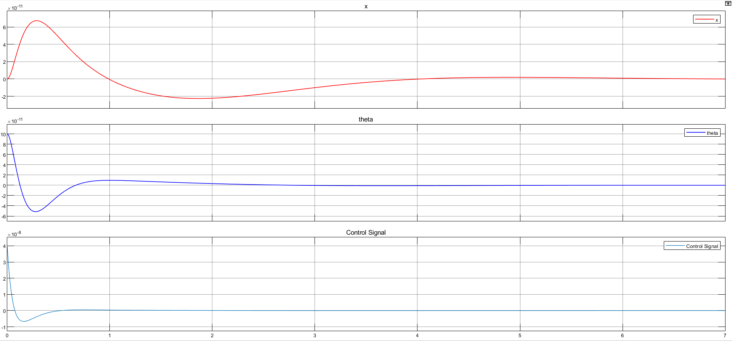

**Fig.** System Response corresponding to linear model

# Response Analysis of Linearized System

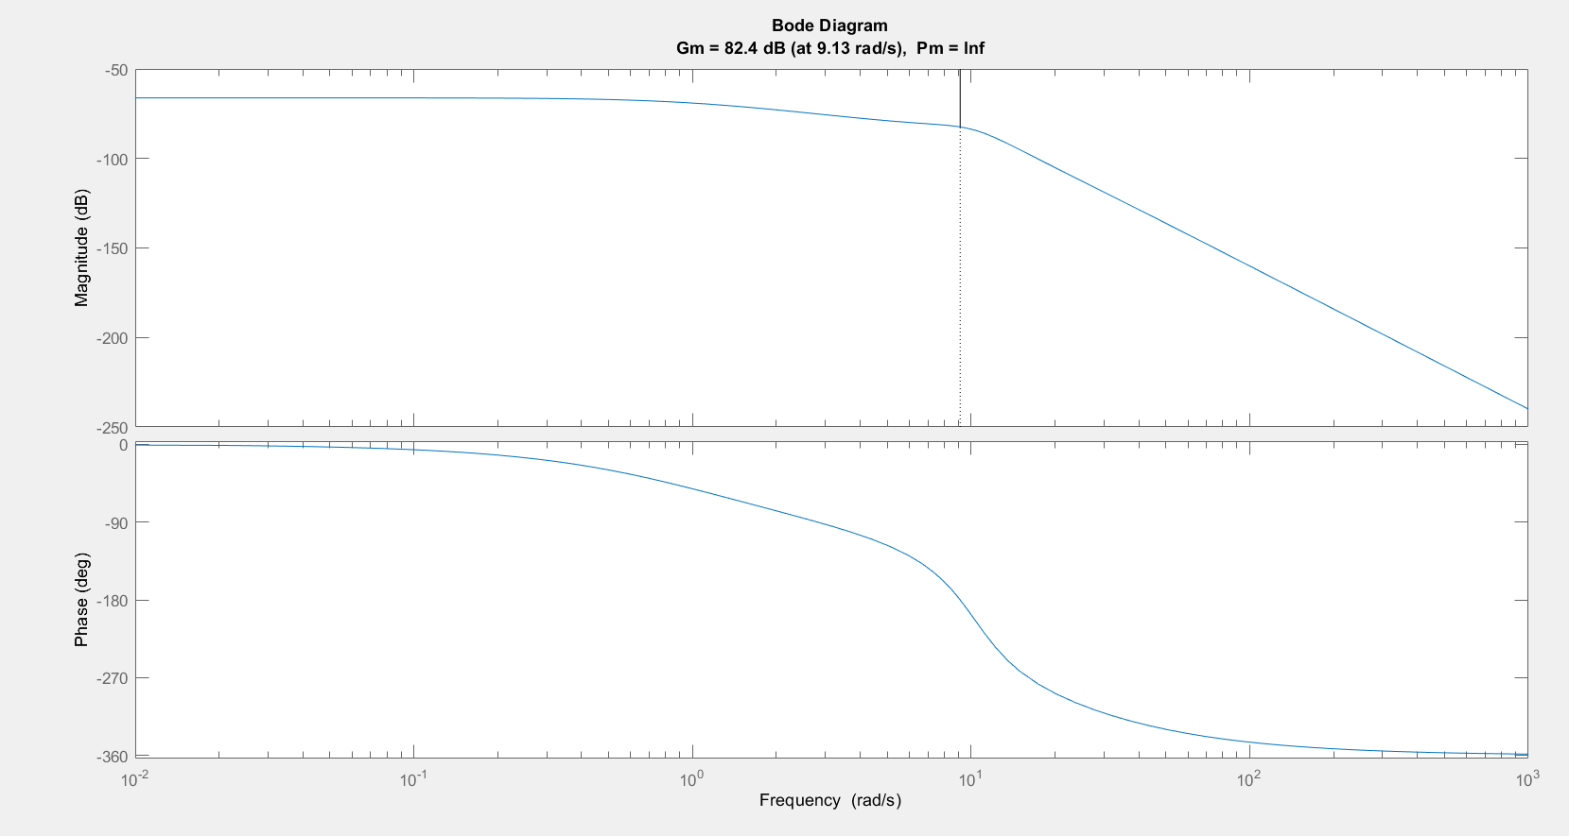

From the plots it can be observed that the maximum overshoot is 35.8% and gain margin is 82.4 dB at 9.13 rad/s.

# Application of Controller on Non-Linear Model

# 

**Fig.** System Response corresponding to non-linear model